1a

My implementation is showed in the code file

1b

The plot of the five regression algorithms

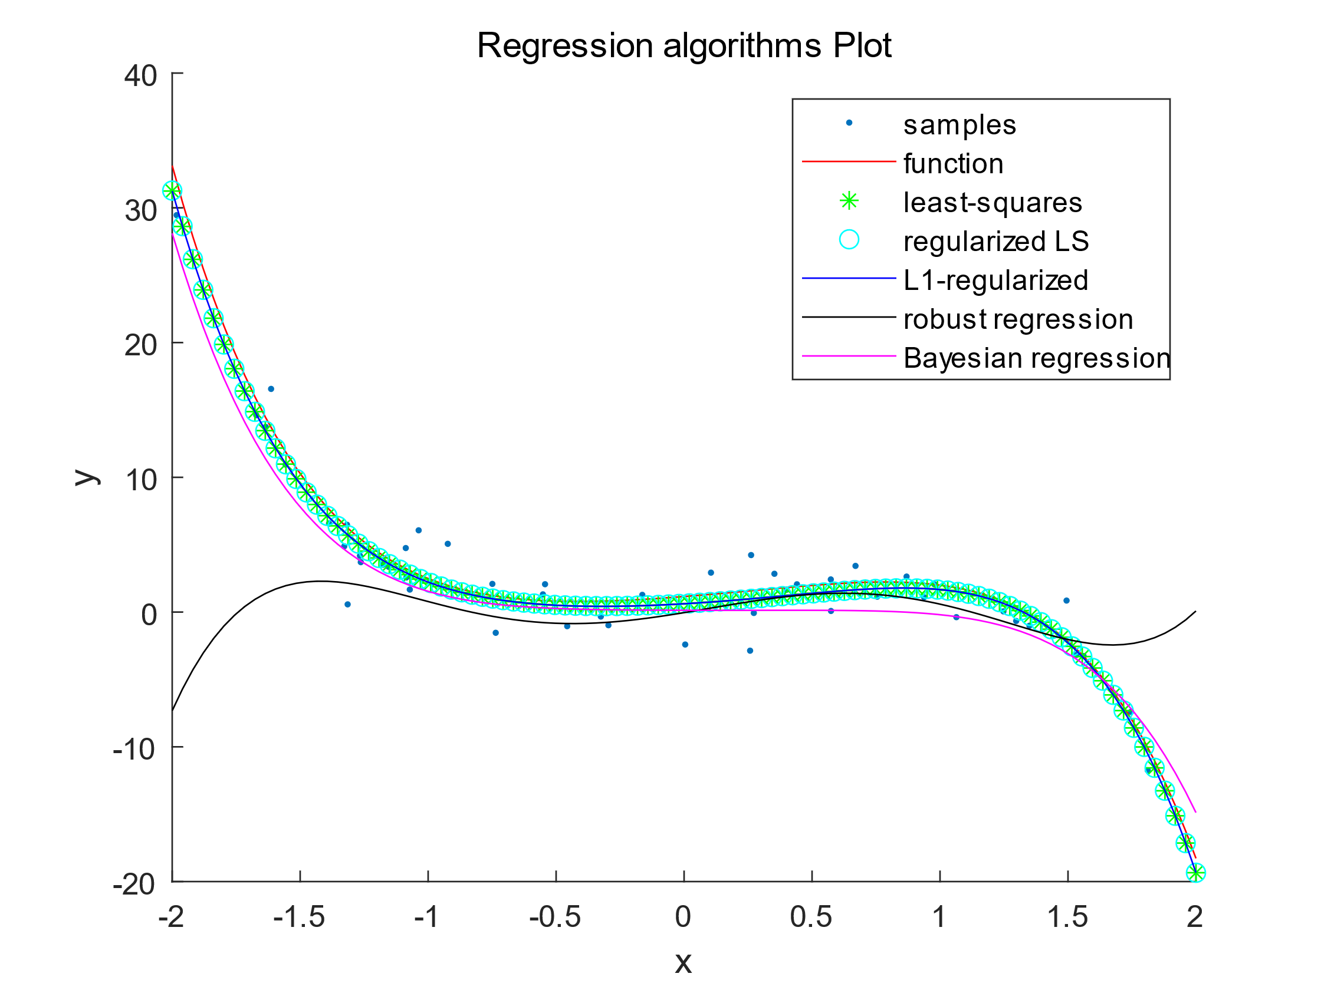

For BR, also plot the standard deviation around the mean.

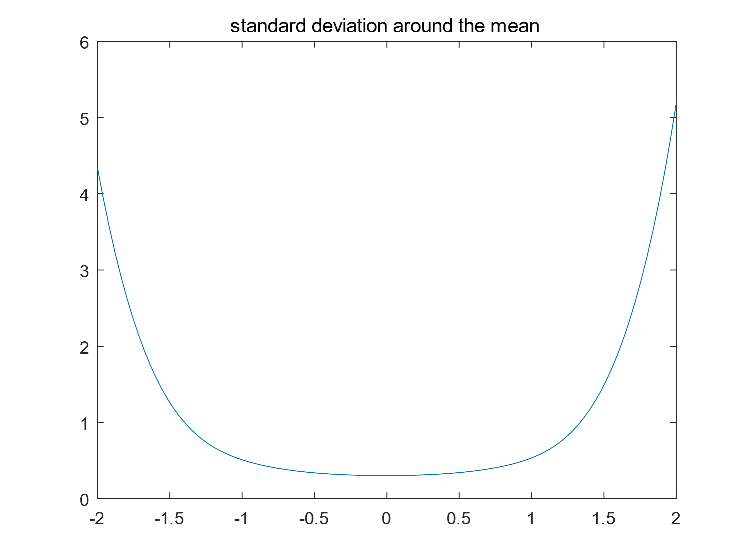

mean-squared error

the least-squares algorithm average mean-squared error is 4.086439

the regularized LS algorithm average mean-squared error is 4.082365

the L1-regularized LS algorithm average mean-squared error is 4.086429

the robust regression algorithm average mean-squared error is 690.879200

the Bayesian regression algorithm average mean-squared error is 39.046120